**SUPPORTING INFORMATION**

**HunStat2 – a Simple and Low-Cost Potentiostat with Electrochemical Impedance Spectroscopy Capability**

Istvan Vamosa, Richard Morrisonb, Sandor Michaletzkyc, Vilmos Kerteszd*

a Lajos Petrik Vocational Chemistry School, Budapest, Hungary

b Retired Scientist, Melbourne, Australia

c Software developer, Budapest, Hungary

d Biosciences Division, Oak Ridge National Laboratory, Oak Ridge, TN, USA

*Corresponding Author:

Vilmos Kertesz

Bioanalytical Mass Spectrometry Group

Biosciences Division

Oak Ridge National Laboratory, Oak Ridge, TN 37831-6131

E-mail: [kerteszv@ornl.gov](mailto:kerteszv@ornl.gov)

Phone: 865-574-3469

This manuscript has been authored by UT-Battelle, LLC, under contract DE-AC05-00OR22725 with the US Department of Energy (DOE). The US government retains and the publisher, by accepting the article for publication, acknowledges that the US government retains a nonexclusive, paid-up, irrevocable, worldwide license to publish or reproduce the published form of this manuscript, or allow others to do so, for US government purposes. DOE will provide public access to these results of federally sponsored research in accordance with the DOE Public Access Plan (<https://www.energy.gov/downloads/doe-public-access-plan>).

**Table of contents**

Details on the AD5941 Chip …………………………….……………..…S-3

Details on the HunStat2 Hardware …………………………….…………S-4

Setup Seeeduino XIAO RP2040 in the Arduino IDE ………………....S-5

The HunStat2 Graphical User Interface Software ……………….……..S-6

Supporting Figures ………………….……………….…………………..…S-7

**S-3 Details on the AD5941 Chip.**

Key components of the AD5941 chip (**Figure S1**):

* LPTIA (Low Power Transimpedance Amplifier): Convert current to voltage.
* LPDAC (Low Power Digital-to-Analog Converter): Generates VZERO and VBIAS
* HSTIA (High-Speed Transimpedance Amplifier): Converts high-bandwith current signals up to 200 kHz into voltage for ADC measurement.
* HSDAC (High-Speed Digital-to-Analog Converter): Generates high-frequency sinusoidal excitation signals.
* DFT (Discrete Fourier Transform) Engine: Performs built-in Fourier transformation to compute the real and imaginary components of impedance.
* FIFO (First In, First Out) Buffer: Temporarily stores measurement data to optimize communication with the microcontroller.
* SPI (Serial Peripheral Interface): Provides data communication between the AD5941 and the microcontroller.

The AD5941 AFE includes essential components for voltammetric measurements: control amplifiers, transimpedance amplifiers (LPTIA), and DACs. The low-bandwidth AFE supports DC techniques, while the high-bandwidth AFE, capable of handling signals up to 200 kHz, is used for EIS. Key components include a high-speed DAC (HSDAC), a frequency generator, and a transimpedance amplifier (HSTIA).

The AD5941’s FIFO (First In, First Out) buffer temporarily stores measurement data for efficient transfer to a microcontroller, minimizing data loss. The chip's programmable gain amplifier (PGA) adjusts signal levels before digitization. The potentiostat control is managed using a XIAO RP2040 microcontroller, interfacing with the AD5941 via SPI. The XIAO RP2040 microcontroller manages HunStat2’s operation, serving as the interface between the potentiostat and the PC-based data processing software. Communication is handled via USB, ensuring stable data transfer while also providing power to the device.

SPI (Serial Peripheral Interface) synchronizes data transfer between the microcontroller (Master) and the AD5941 (Slave) using dedicated lines: MOSI (Master Out, Slave In), MISO (Master In, Slave Out), SCLK (Clock), and CS (Chip Select).

The AD5941 supports amperometry, chronoamperometry, cyclic voltammetry, square wave voltammetry, and EIS.

**S-4 Details on the HunStat2 Hardware.**

The key circuit of the EIS potentiostat is the AD5941 chip.[1] The chip is a very small 7x7 mm, 48-pin lead frame chip scale package (LFCSP) integrated circuit. Soldering is possible with the help of a stencil ordered together with the printed circuit board (PCB), see **Figure S2a/S2b**. The stencil is a very thin metal plate, on which cutouts are made at the surface-mount device (SMD) pad location using a laser beam. First, tin paste is applied to the solder pads on the PCB through the stencil, then the components are placed on the panel and heated appropriately (with a heat gun or in a so-called reflow oven). The radiated heat melts the tin paste and the components solder in by themselves. The PCB board can be ordered based on Gerber file accessible from the authors. It is also possible to order a ready-made mounted circuit board, for which the authors also provide the necessary bill of materials (BOM) PCB file. **IMPORTANT:** To be able to measure OCP, the reference electrode must be connected to AIN3 pin on the board as shown in **Figure S3** below.

To ensure reproducibility and broaden accessibility, the complete device can also be obtained in an assembled form. This option is particularly relevant in situations where manual assembly may be hindered by the need for stencil-based soldering procedures or by limited experience with fine-pitch SMD components. The provision of Gerber, Pick-and-Place, and BOM files in the accompanying GitHub repository enables straightforward integration into professional PCB manufacturing and assembly workflows.

**S-5 Setup Seeeduino XIAO RP2040 in the Arduino IDE**.

The first step is to add Seeed Studio XIAO RP2040 board package to your Arduino IDE.[2] For this, select the ***File/Preferences*** menu in the Arduino IDE, and put <https://github.com/earlephilhower/arduino-pico/releases/download/global/package_rp2040_index.json> in the *Additional Boards Manager URLs* field (**Figure S4**) and click OK.

In order for the Arduino IDE to handle the Seeeduino XIAO RP2040, navigate to *Tools*/*Board/Boards Manager*... menu, type the keyword "*RP2040*" in the search bar. **IMPORTANT :** Select **version 2.7.1**. of "*Raspberry Pi Pico/RP2040*" board and install it (**Figure S5**). (In our experience, later versions (as of July 1, 2025) don’t work with the board.) After that, select the XIAO RP2040 board from the *Tools/Board* menu (**Figure S6**) and the appropriate port. **NOTE:** Another option is opening <https://wiki.seeedstudio.com/XIAO-RP2040-with-Arduino/> and following the instructions.

The sketch program for the RP2040 can be downloaded from the GitHub ([AD5941_25.zip](https://github.com/hunstat2/HunStat2/blob/main/AD5941_25.zip)) of [3] and upload them to the RP2040. Additional instructions can be acquired from the authors directly, free of charge.

**S-6 The HunStat2 Graphical User Interface Software.**

The HunStat2 GUI software can be downloaded from the GitHub ([HunStat2-v700 (1).exe](https://github.com/hunstat2/HunStat2/blob/main/HunStat2-v700%20(1).exe)) of [3] place the files into an empty folder on your computer. After connecting the potentiostat, and launching the GUI, the initial screen will appear (**Figure S7**). **Figure S8** shows an example screenshot after an EIS measurement. The icons shown in the top row, from left to right: **Open file, Save file, Start measurement, Clear zoom, Save plot (into a PNG file), Redraw current measurement, Settings, Information**. The software can handle three electroanalytical techniques: cyclic voltammetry (CV), open circuit potential (OCP), and electrochemical impedance spectroscopy (EIS). Parameters for these techniques can be adjusted in the **CV**, **Open Circuit Potential** and **EIS** tabs. Additionally, the **Signal processing** tab allows smoothing of the resulting voltammogram in two different ways (Savitzky-Golay or moving average smoothing). Communication between the GUI and the potentiostat can be monitored in the **Log** tab.

Critical quantitative information can be obtained from the peak heights of recorded CV curves. To do this, you need to draw a baseline. This can be done by holding down the *Shift* button and clicking the left mouse button. When placing the cursor over the desired peak, the peak height relative to the baseline (*Ipeak*) can be read in the upper right corner. A more detailed manual can be downloaded from [3] or directly asked from the authors.

Before making a real analytical measurement, it is advisable to perform the a simple checks.

Connect a given resistor between the shorted CE-RE point and the WE, and run the potential between 0 and 1 V. If the circuit is functioning properly, an increasing current with increasing voltage is observed. Current at 1 V should be equal to 1 V divided by the resistor’s value.

For further questions or development suggestions, the authors can be contacted directly.

**SUPPORTING FIGURES**

**A képen szöveg, diagram, képernyőkép, Betűtípus látható

Előfordulhat, hogy a mesterséges intelligencia által létrehozott tartalom helytelen.**

***Figure S1*** *Block diagram of AD5941 chip and connected devices.*

***Figure S2-a*** *PCB layout and stencil of the HunStat2 circuit.*

A képen elektronika, szöveg, Elektrontechnika, áramkör látható

Előfordulhat, hogy az AI által létrehozott tartalom helytelen.

***Figure S2-b*** *The PCB board with SMD components embedded*

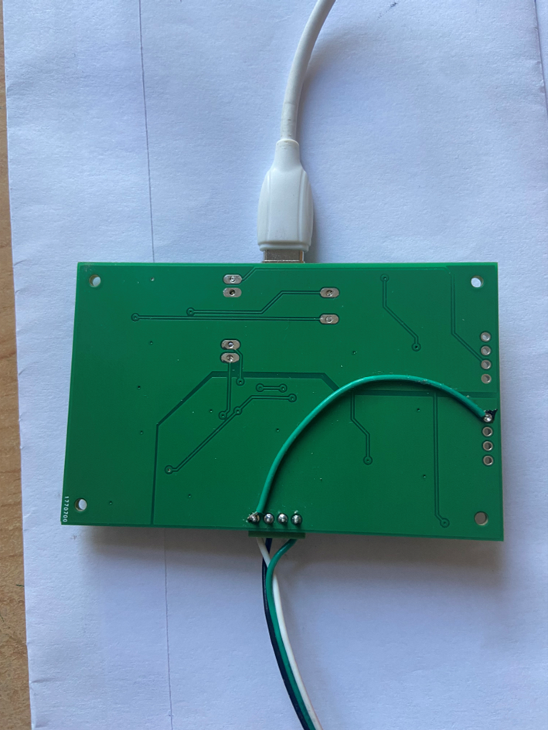

***Figure S3*** *Reference electrode (bottom leftmost connector) must be connected to AIN3 pin (right side) on the board to be able to measure OCP.*

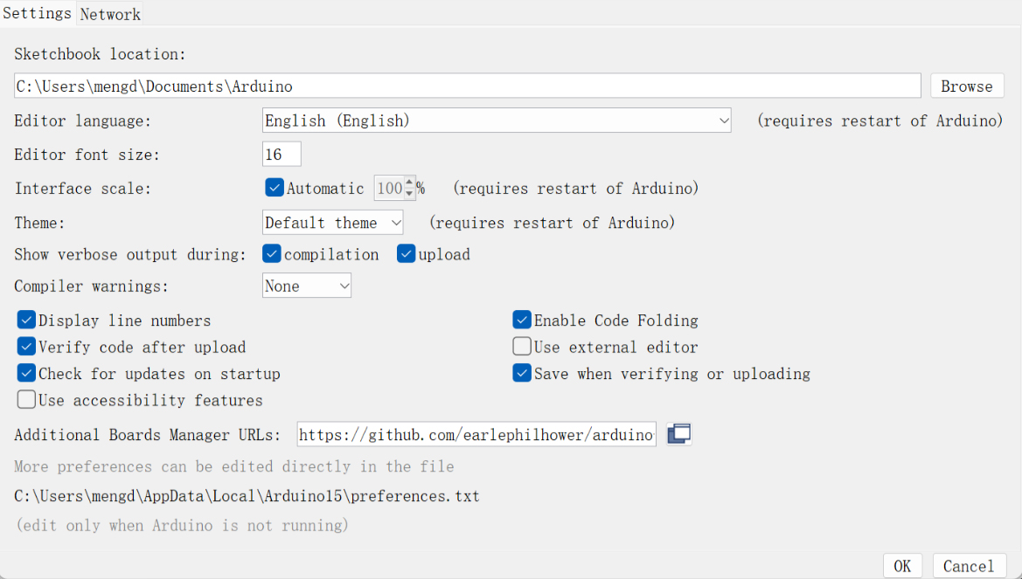

***Figure S4*** *Setting up additional boards in the Arduino IDE.*

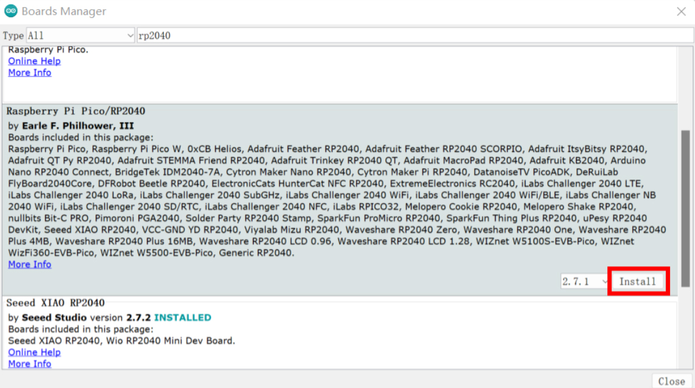

***Figure S5*** *Installing the Raspberry Pi Pico/RP2040 board driver.*

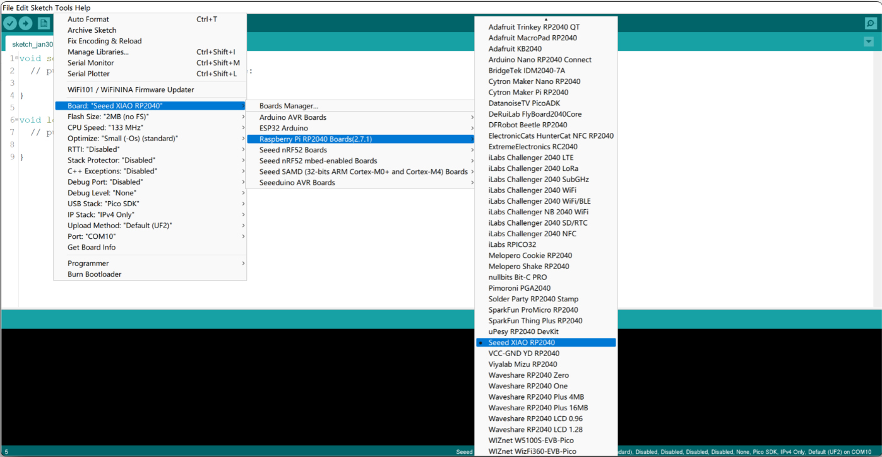

***Figure S6*** *Selecting the XIAO RP2040 board.*

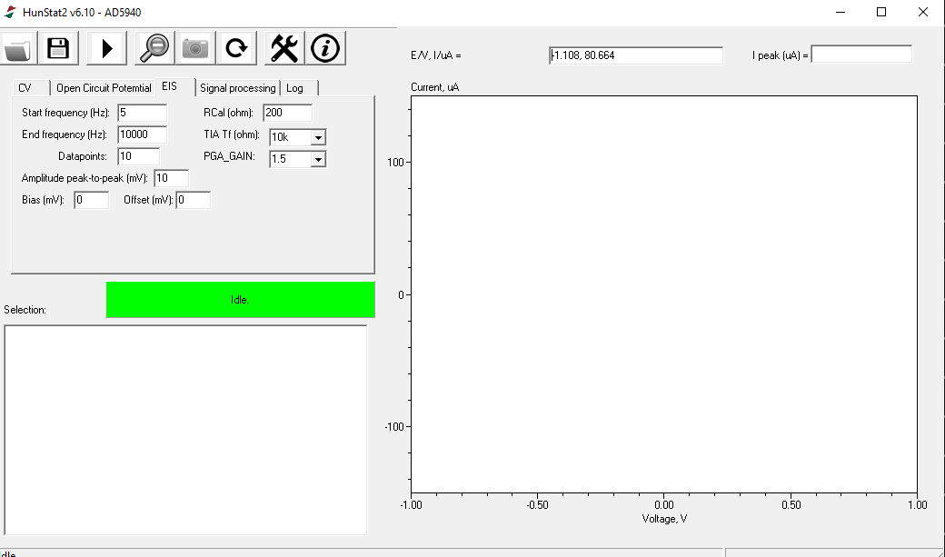

***Figure S7*** *Main screen of the HunStat2.exe software after start.*

*A képen szöveg, képernyőkép, diagram, Diagram látható

Előfordulhat, hogy az AI által létrehozott tartalom helytelen.*

***Figure S8a.*** *Main screen of the HunStat2.exe software after an EIS measurement. (Figure S8a. shows the Bode plot of the same Randles dummy cell as the Nyquist plot shown in Figure S8b.)*

*A képen szöveg, képernyőkép, diagram, Diagram látható

Előfordulhat, hogy az AI által létrehozott tartalom helytelen.*

***Figure S8b.*** *Main screen of the HunStat2.exe software after an EIS measurement.*

**REFERENCES**

[1] <https://www.analog.com/en/products/ad5941.html>. Last accessed June 5, 2025.

[2] <https://www.arduino.cc> . Last accessed June 5, 2025.

[3] https://github.com/hunstat2/HunStat2

Last accessed Oct. 5, 2025.